**Khasenova Kamila  
SE-2205**

**Assignment 1**

**Report**

**1)Exploratory Testing.**

At first I explored the keys and here I leaved fields blank, entered an invalid tracking number and submit the form to check for validation messages:

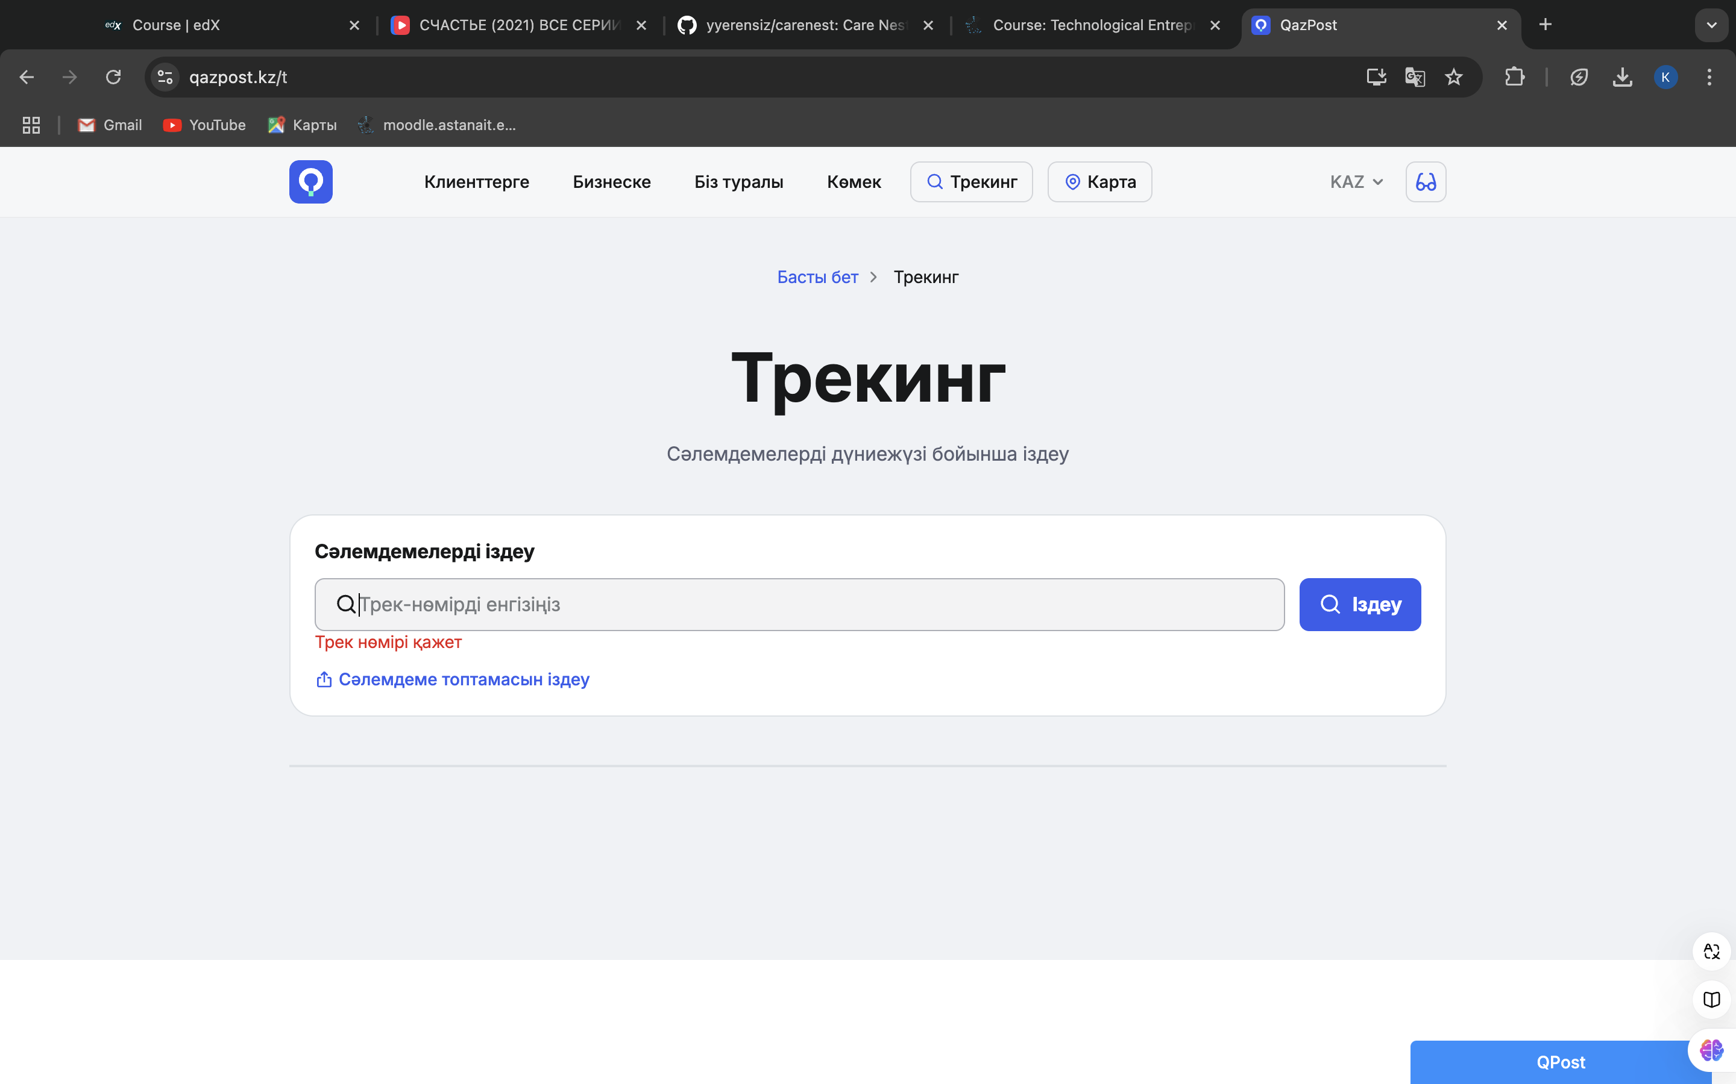

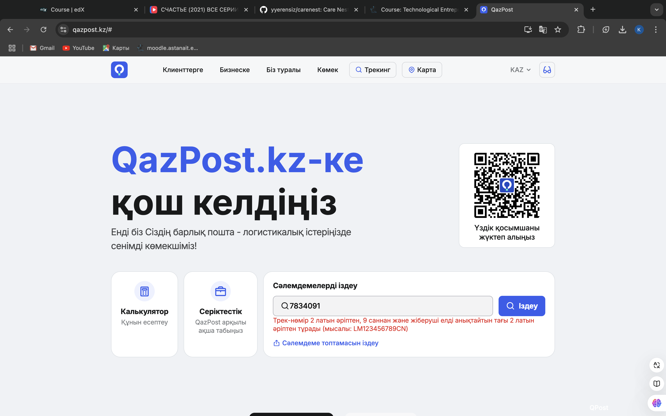

I checked if switching between languages is working well and no problem was found, except one, when the error message was not changed:

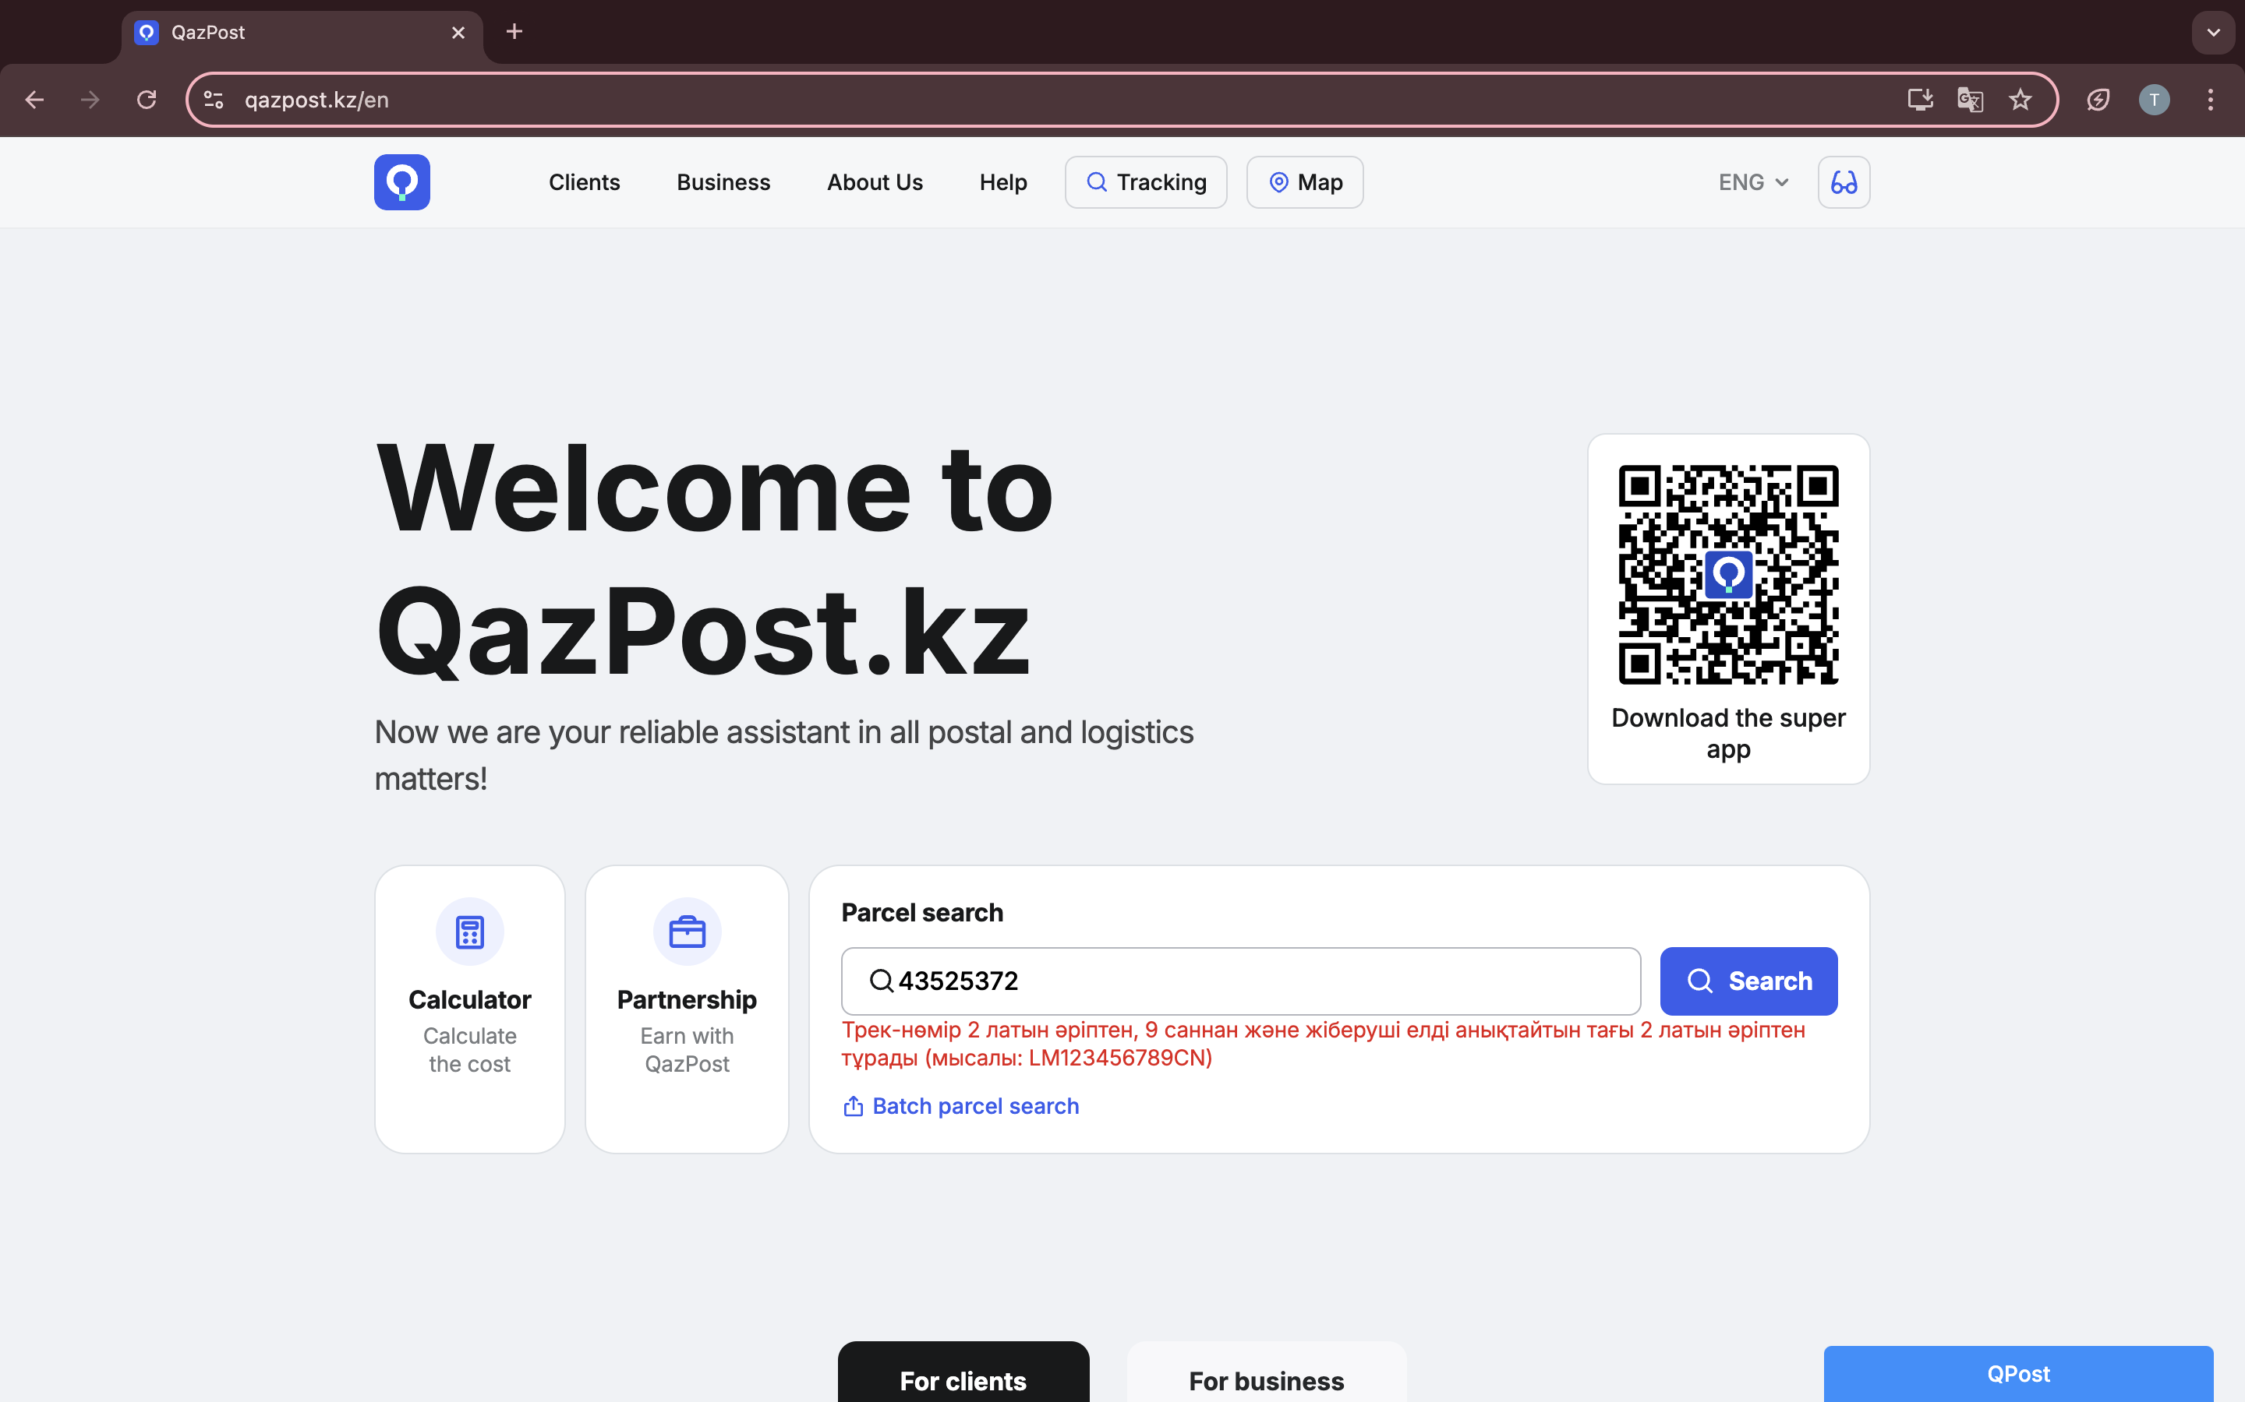

Also I decided to choose <https://github.com/> site for my testing.

I did not find any bugs at the authorization part, it asks for mail verification and gives all error messages:

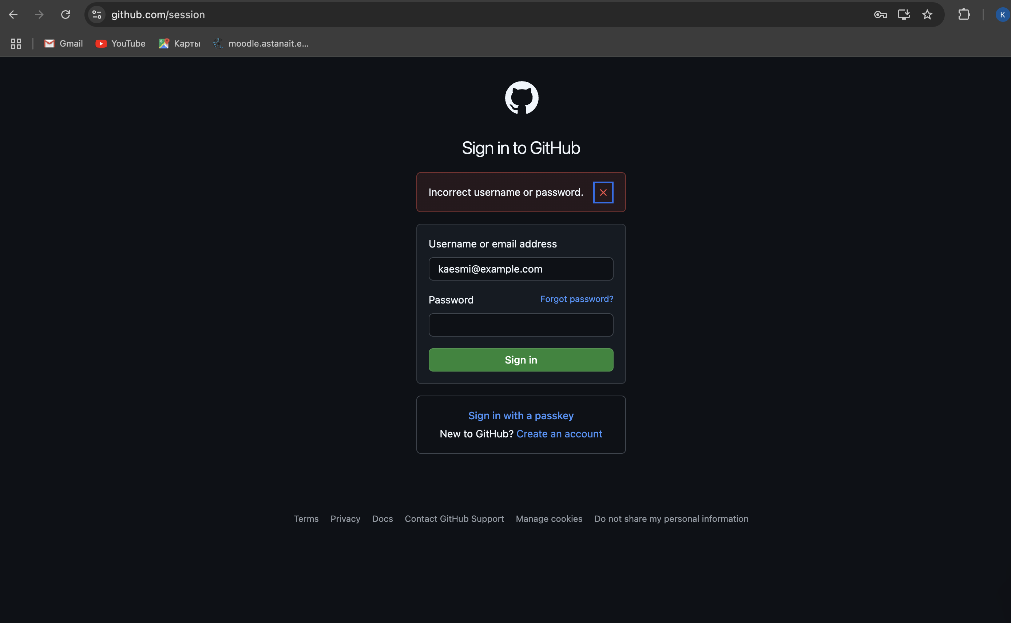

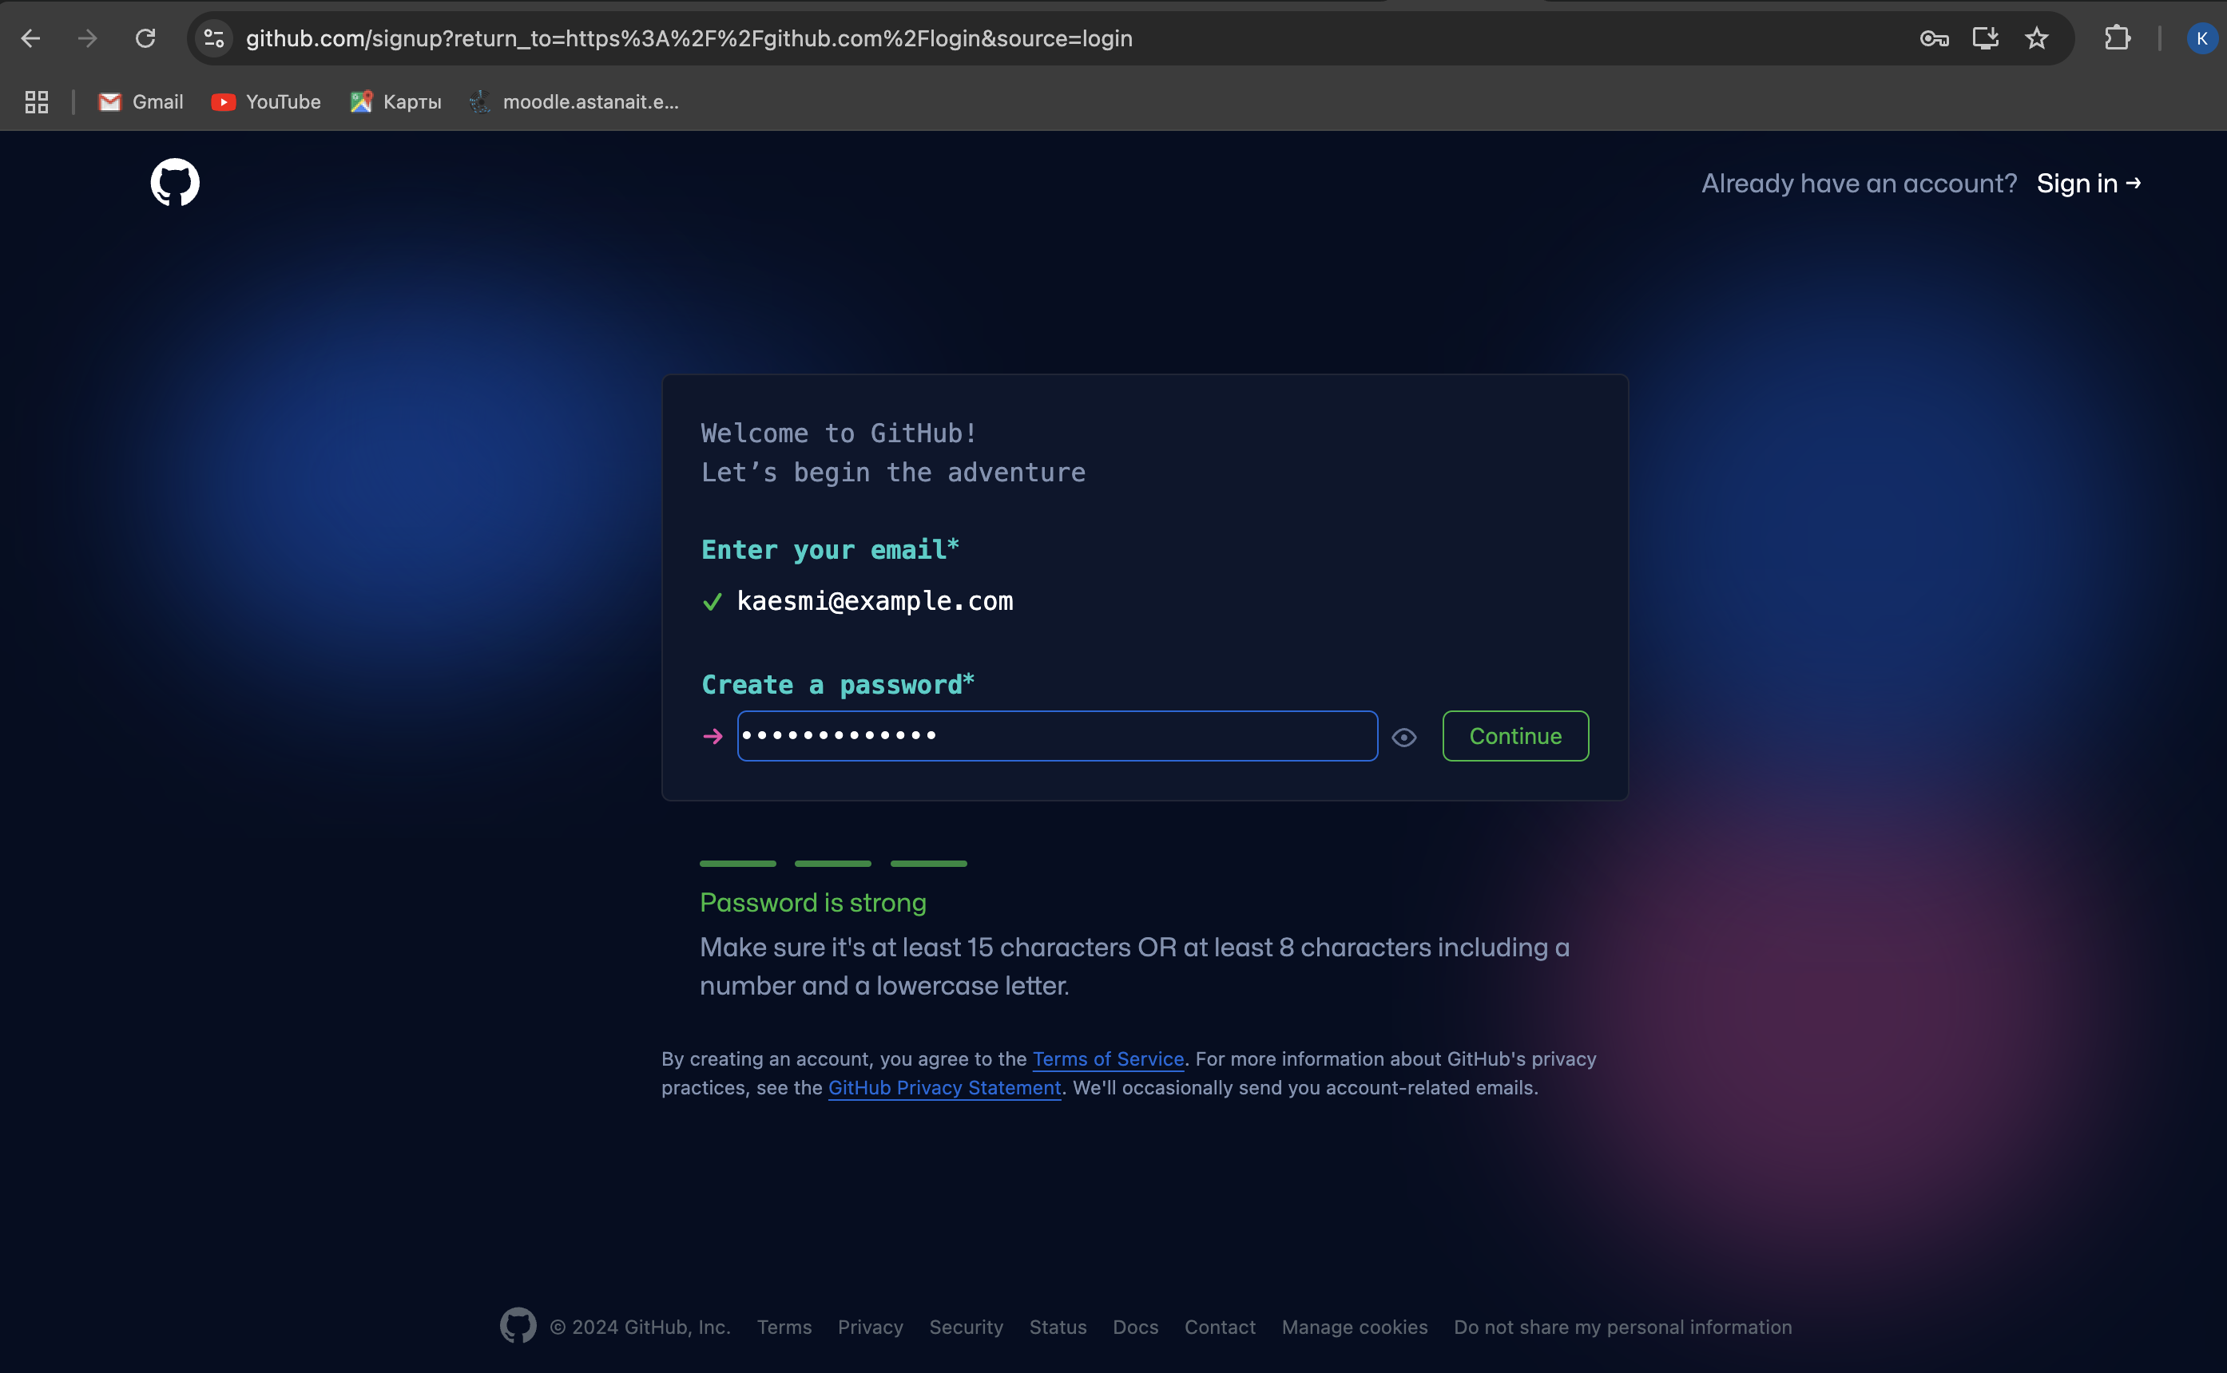

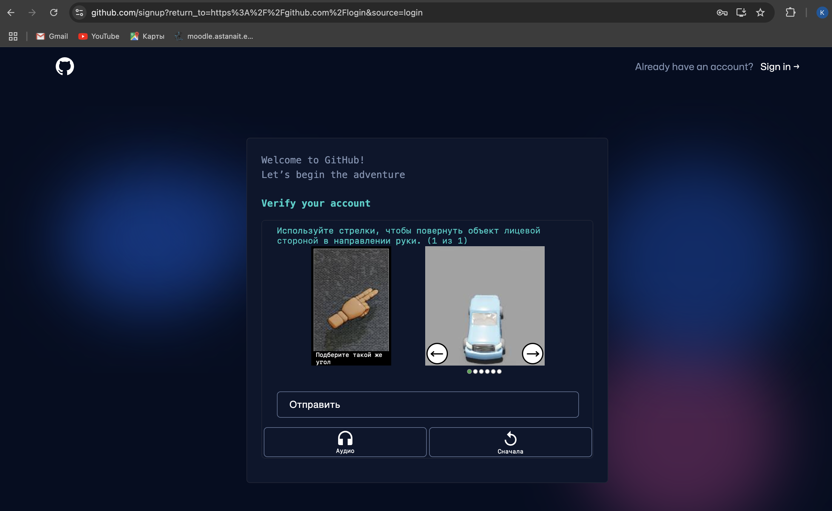

Here I entered invalid code:

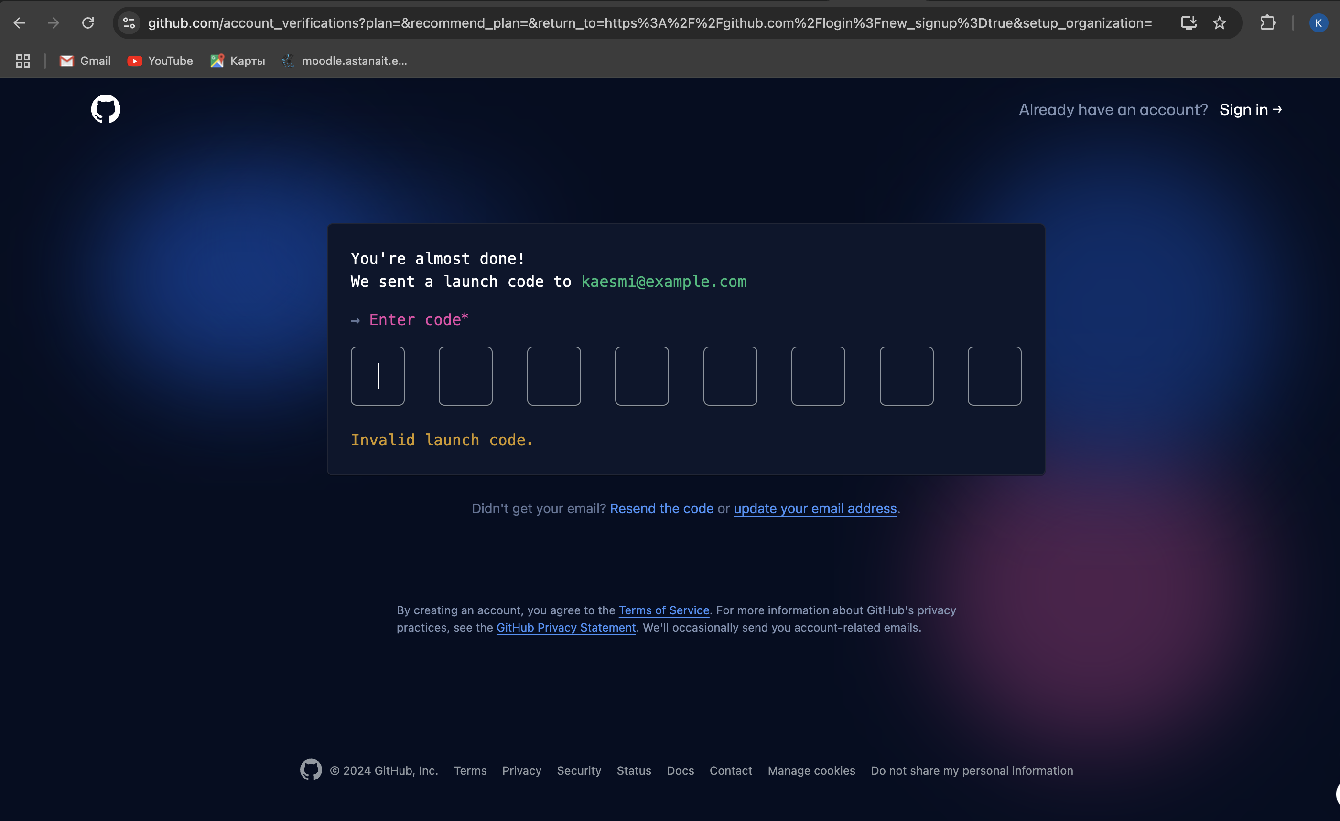

The session storage for github.com is functioning correctly, with all keys and values intact, indicating no visible bugs:

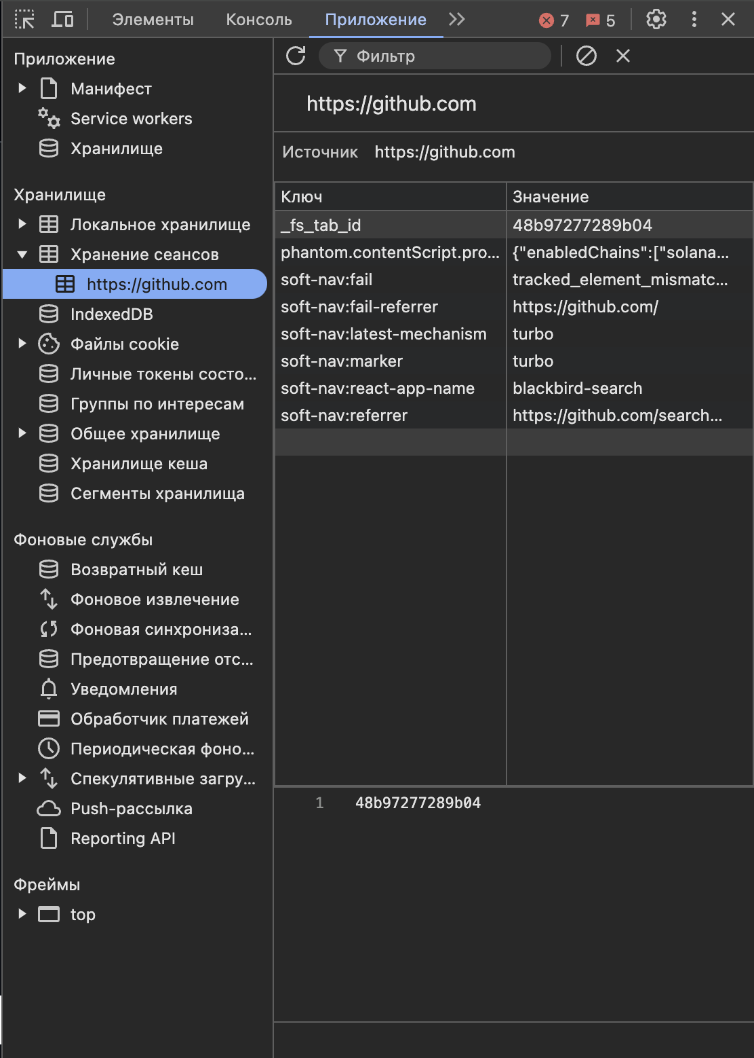

When I tested search bar, I found the bug:

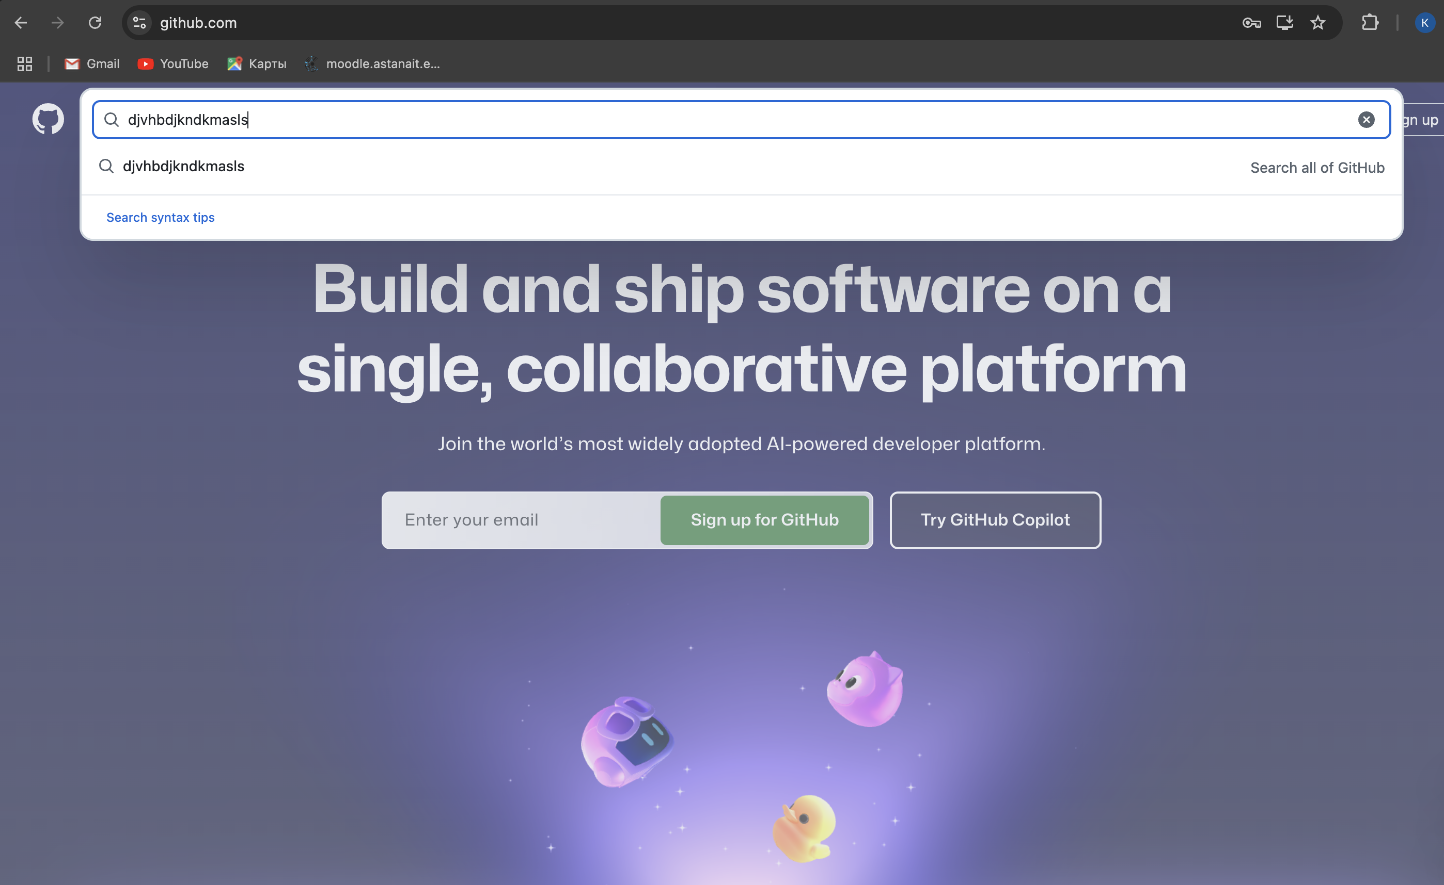

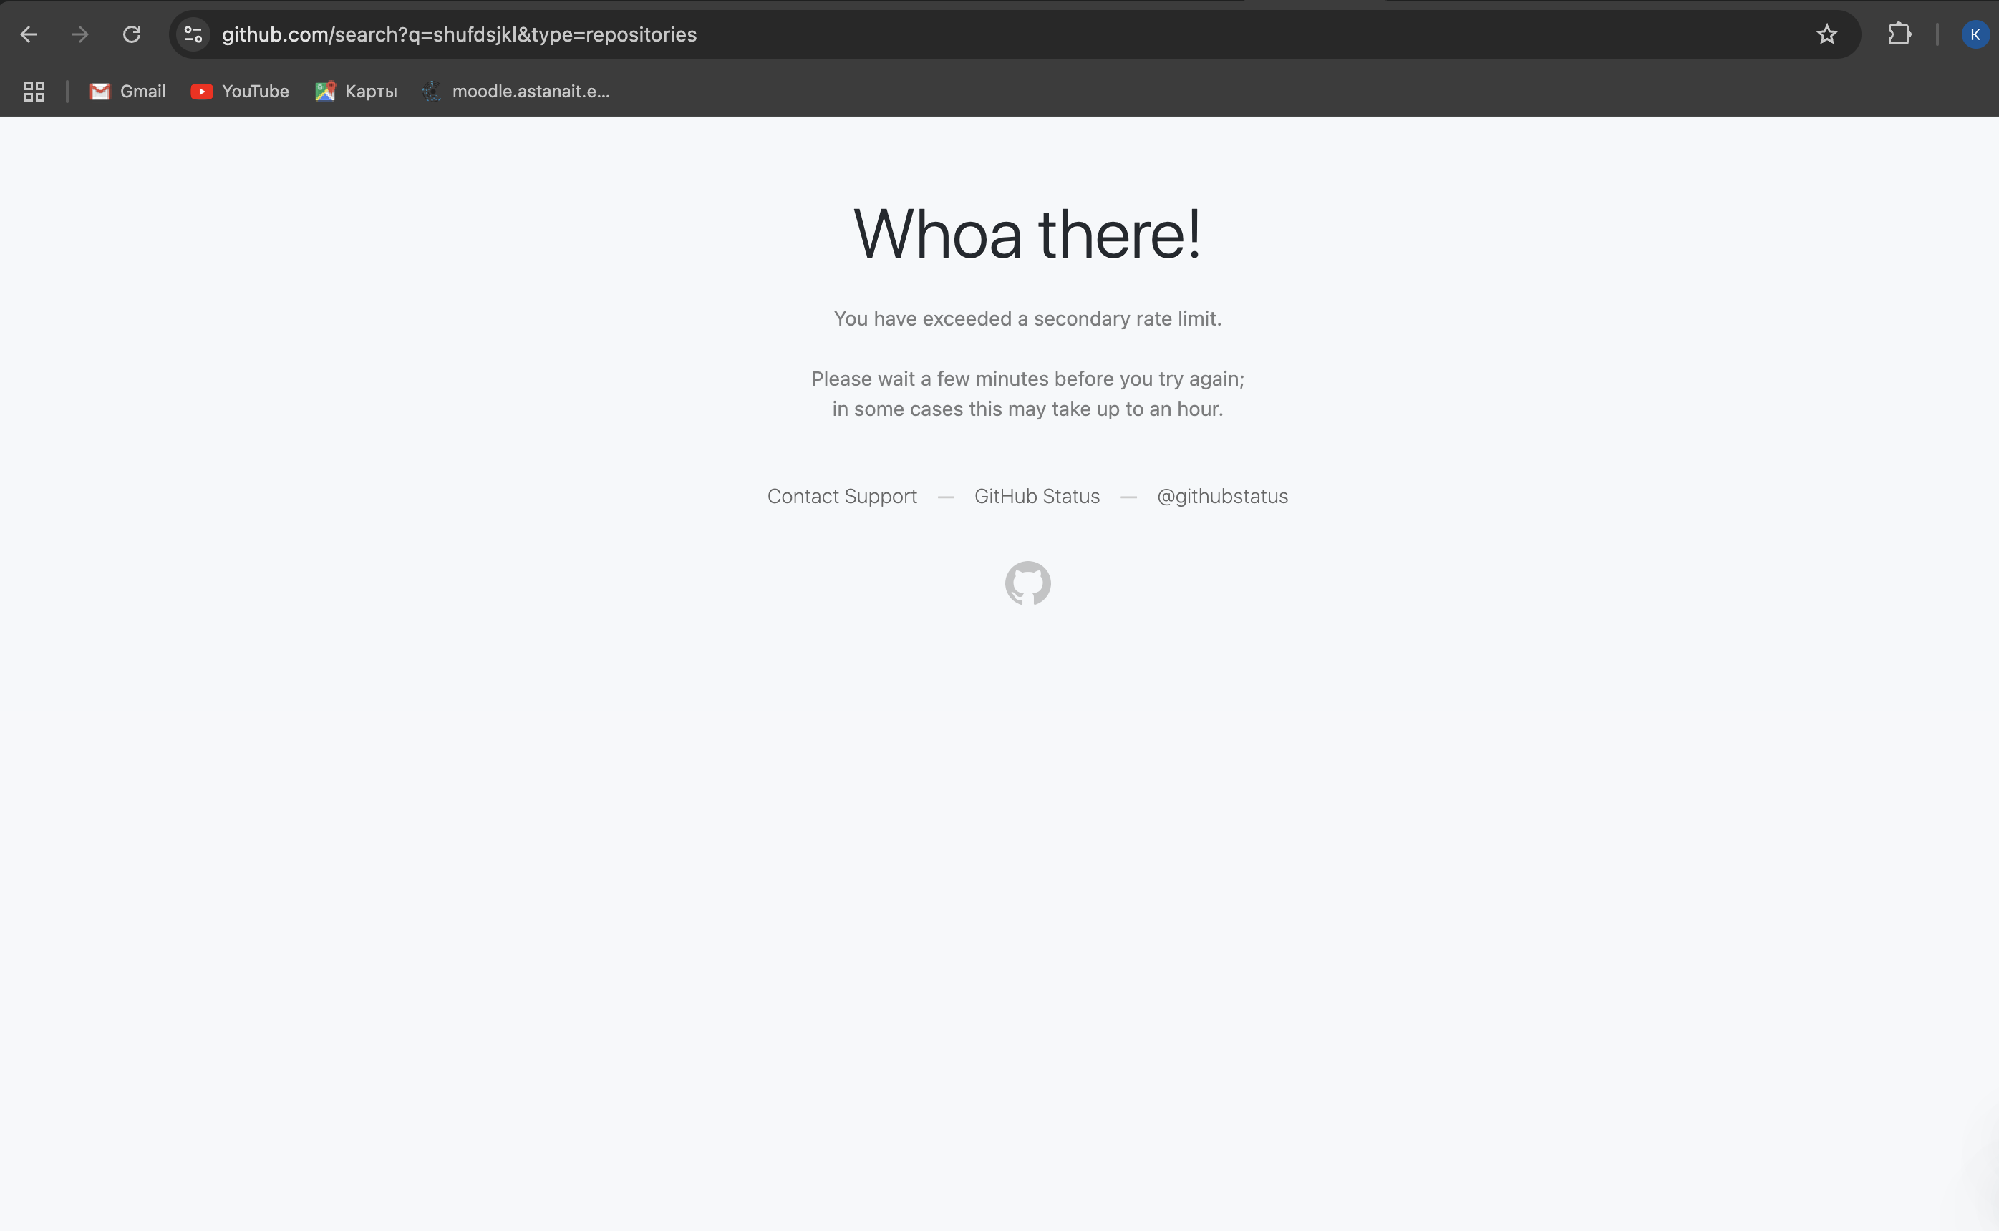

**2) Test Planning.**

**Test Objectives**

1. Verify that the github.com website functions as intended and meets all user requirements.
2. Ensure that all critical features correctly.
3. Confirm compatibility with multiple devices, browsers, and screen resolutions.
4. Identify and report any usability issues, functional errors, or performance bottlenecks.

**Scope**

* User authentication and registration.
* Access to public services.
* User interface and usability testing.
* Mobile responsiveness and cross-browser compatibility.
* Backend infrastructure.

**Schedule and Logistics**

|  |  |  |
| --- | --- | --- |
| Task | Day | Responsible Person(s) |
| Test Plan Creation | Day 1 | QA Lead |
| Environment Setup and Configuration | Day 2 | QA Engineers |
| Smoke Test Suite Execution | Day 3 | QA Testers |
| Functional Testing (Core Features) | Day 4-6 | QA Testers |
| UI/UX and Compatibility Testing | Day 7-8 | QA Testers |
| Regression Test Suite Execution | Day 9-10 | QA Testers |
| Bug Reporting and Final Report | Day 11 | QA Lead |

**Test Environment**

**Hardware**: Windows 10, macOS, phone.

**Software**: Chrome, Safari.

**Network**: Stable internet, VPN if needed.

**Test Strategies/Methods**

1. **Functional Testing**: Validate core functionalities like login, service application, and payments.
2. **UI/UX Testing**: Evaluate website design, navigation, and responsiveness.
3. **Compatibility Testing**: Check performance across multiple devices and browsers.
4. **Performance Testing**: Test response times and page loading under normal and heavy traffic conditions.
5. **Security Testing**: Ensure secure login, data encryption, and no unauthorized access to sensitive data.

**Test Cases**

**Example Test Cases**:

1. **Login Module**:

1. Verify successful login with valid credentials.

2. Ensure error message appears with invalid credentials.

3. Check "Forgot Password" functionality.

1. **Search Feature**:

4. Verify search results for a valid query.

5. Ensure error handling for invalid search inputs.

1. **Service Application**:

6. Validate application submission with valid details.

7. Check error handling for missing or incorrect data in forms.

**4. Payments**:

8. Verify payment success with valid details.

9. Ensure appropriate error message for declined transactions.

**Bug Report:**

* **Bug ID**
* **Module**
* **Description**
* **Severity**
* **Status**

**Risks**

1. Network outages during testing.
2. Incomplete or outdated documentation for the eGov.kz website.
3. Limited availability of certain real-world test scenarios.

**Procedures for Handling Problems**

1. Report issues in the JIRA tool with clear reproduction steps.
2. Escalate critical issues to the development team immediately.
3. Retest and validate fixes after bugs are resolved.

**3) Test Case Creation for Smoke Test Suite and Regression Suite**

A test suite is a collection of test cases designed to validate that a system or application meets its requirements.

**Smoke Testing**

**Objective**: Verify that the most critical functionalities of the github.com system work correctly.

**Test Cases for Smoke Testing**:

1. Verify user can log in with valid credentials and if invalid it gives an error message.

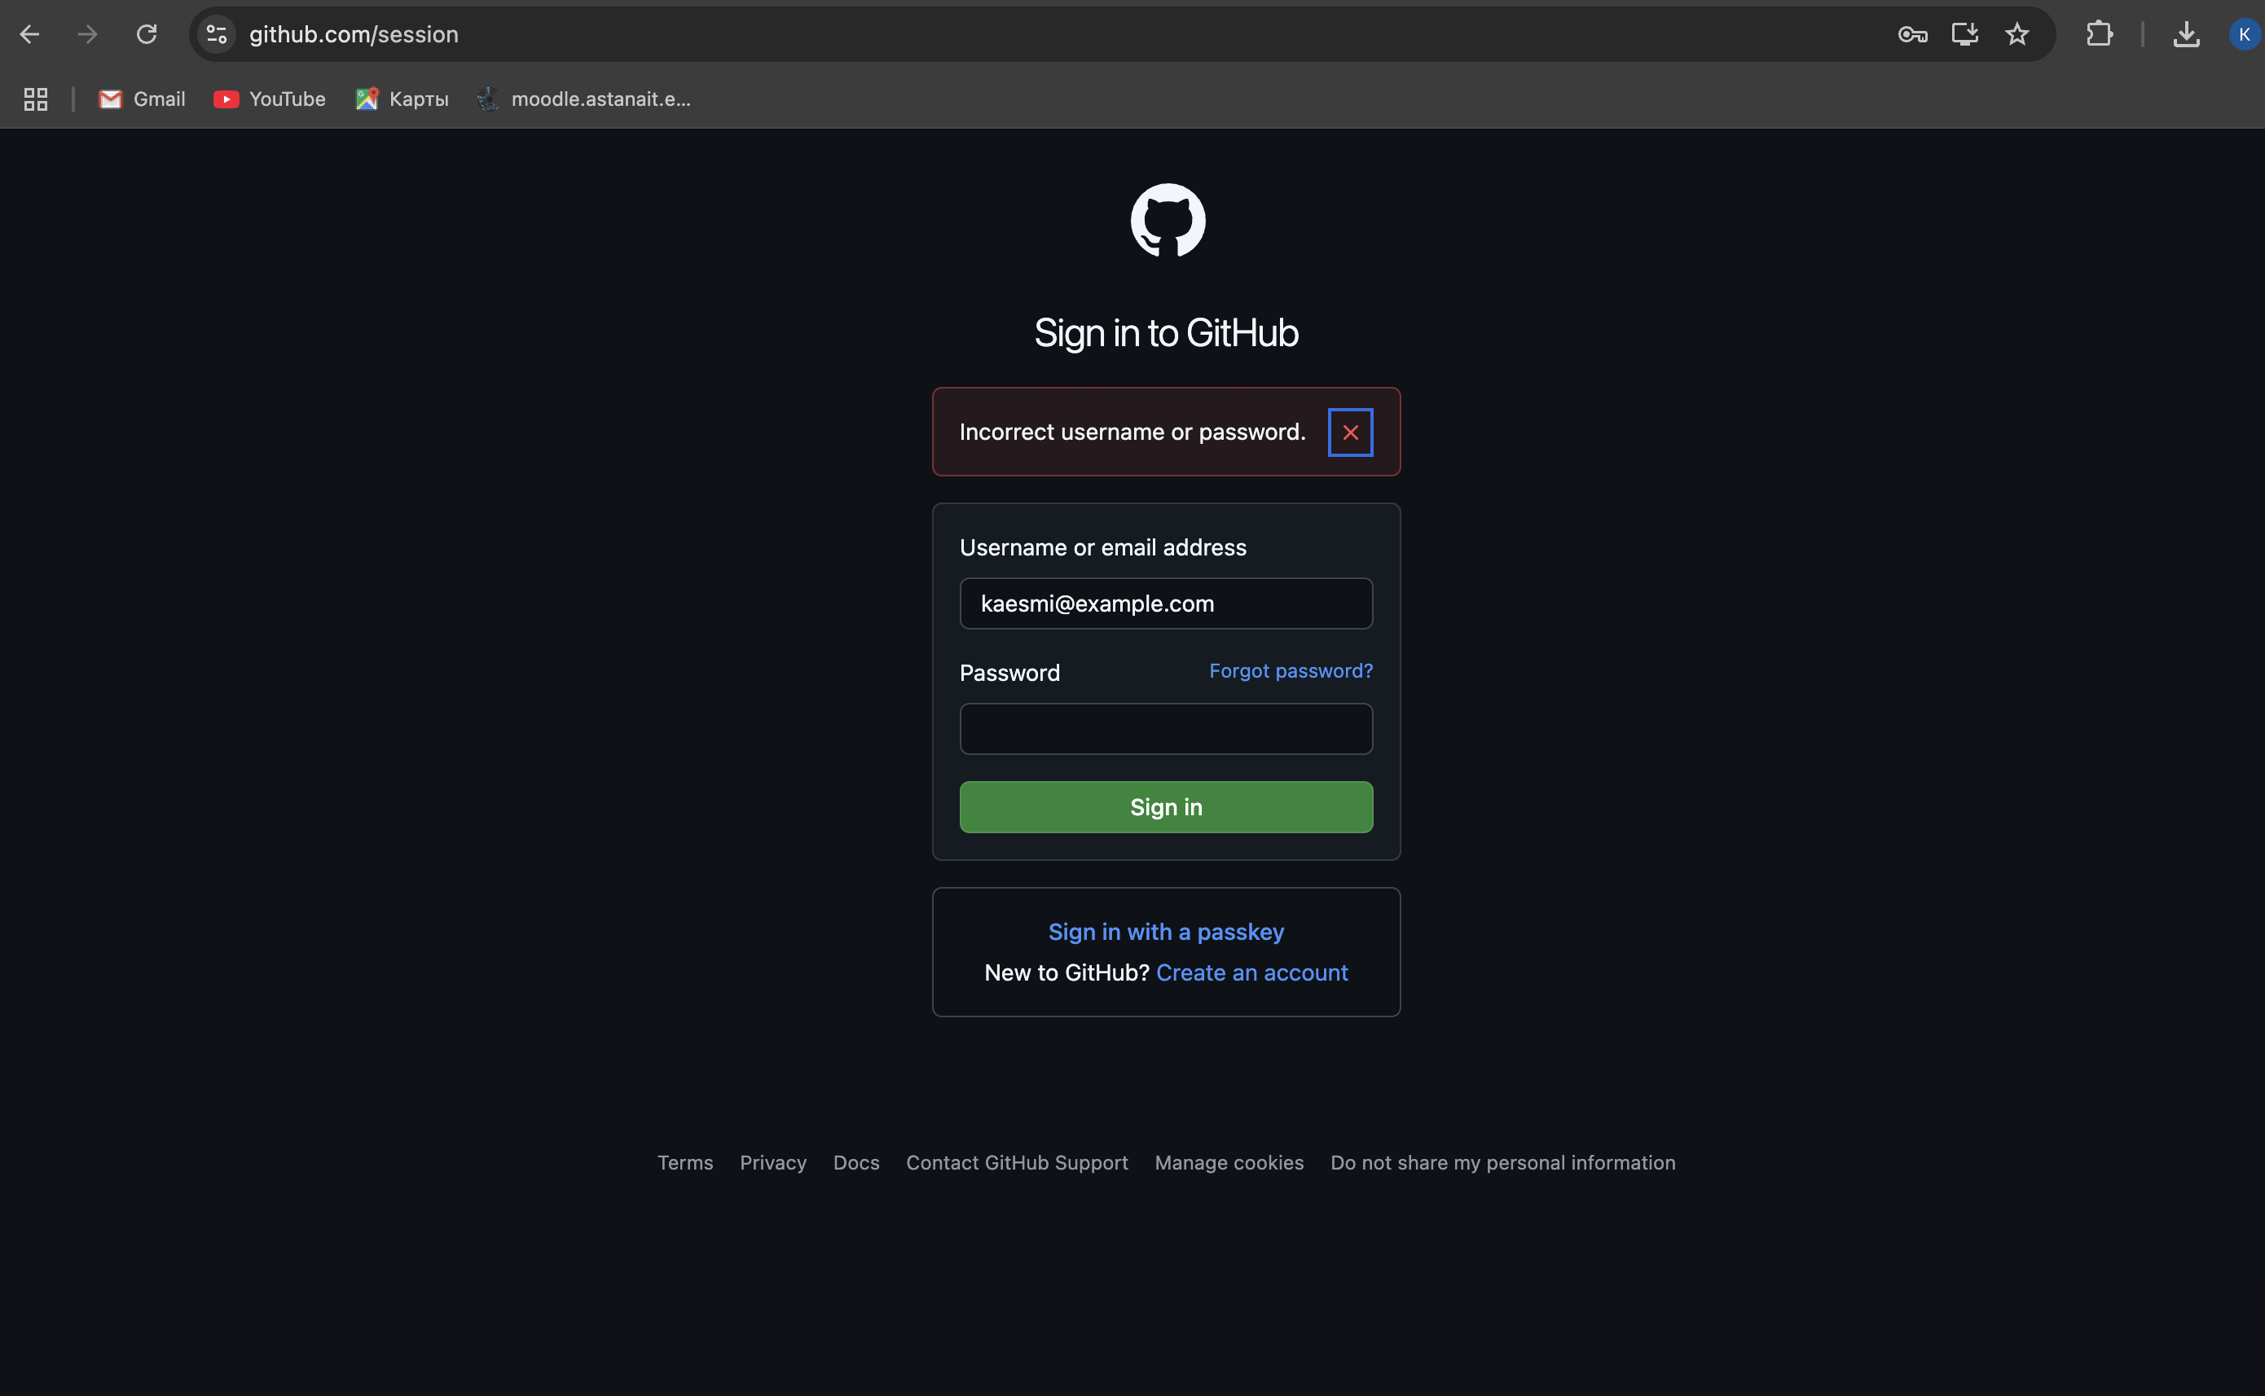

1. Ensure the homepage loads successfully.

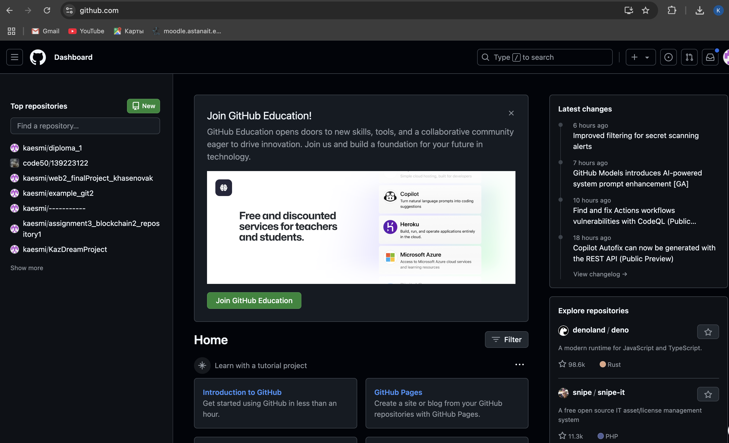

1. Validate that users can search for a service.

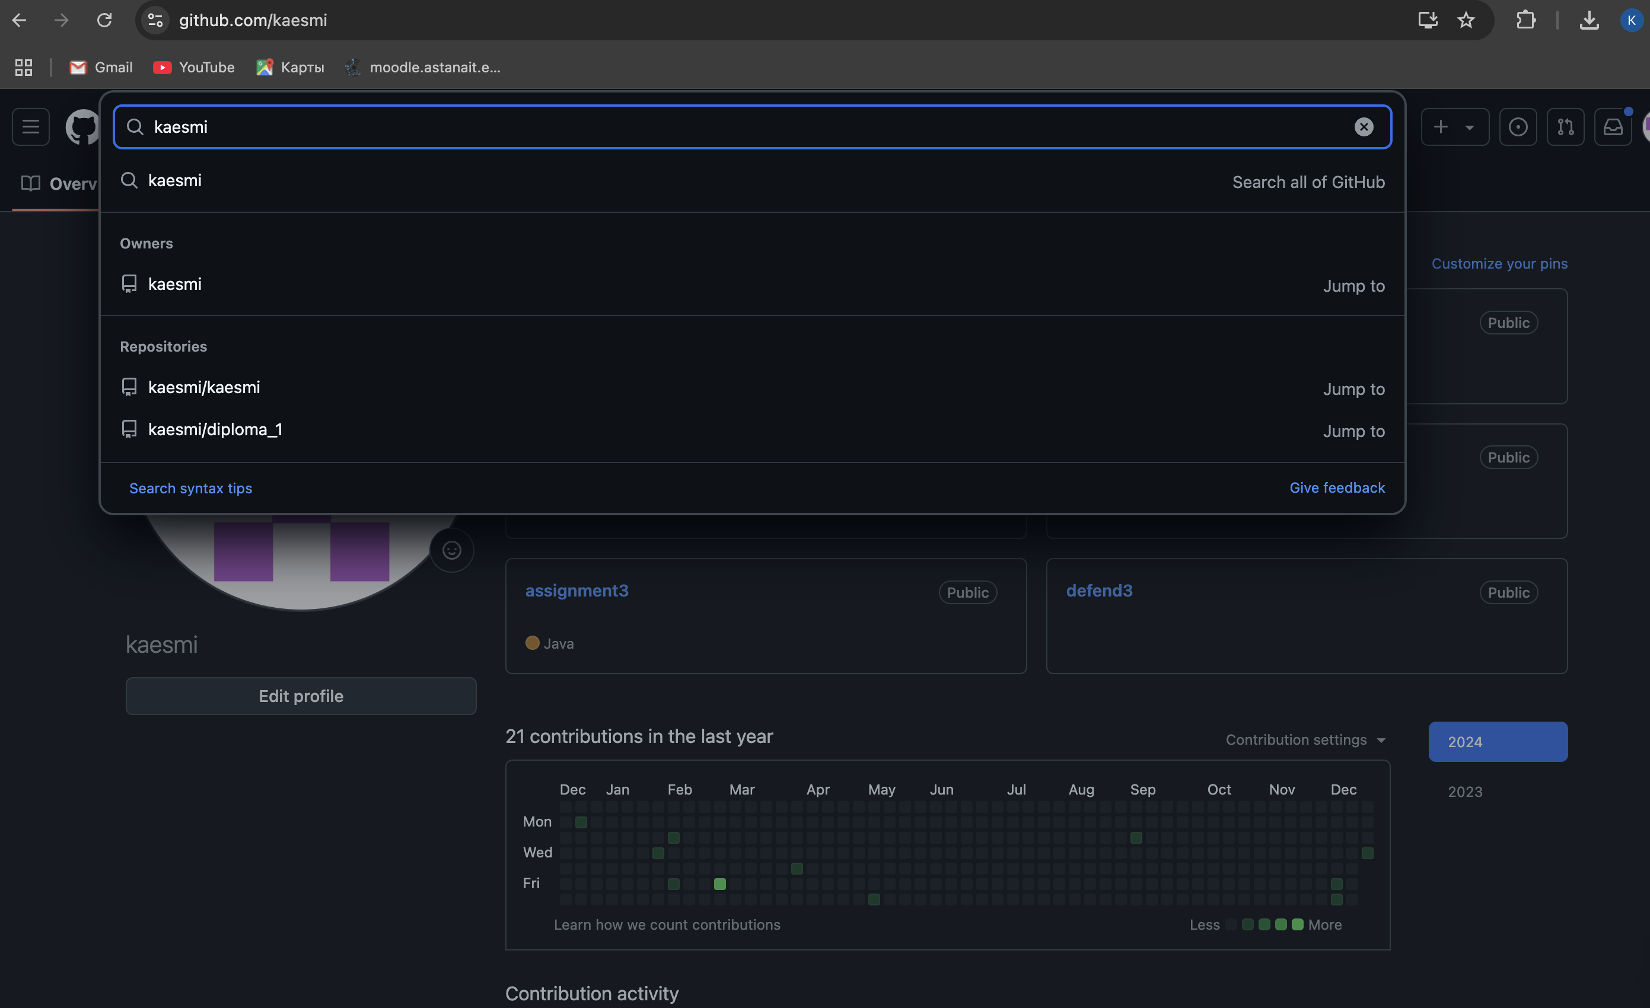

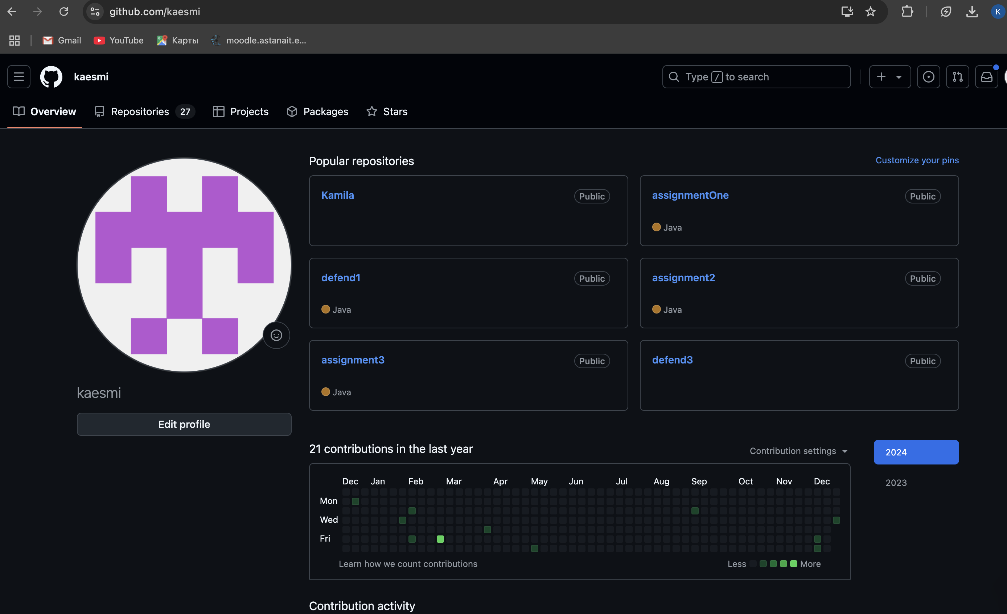

1. Confirm successful submission of an application form.

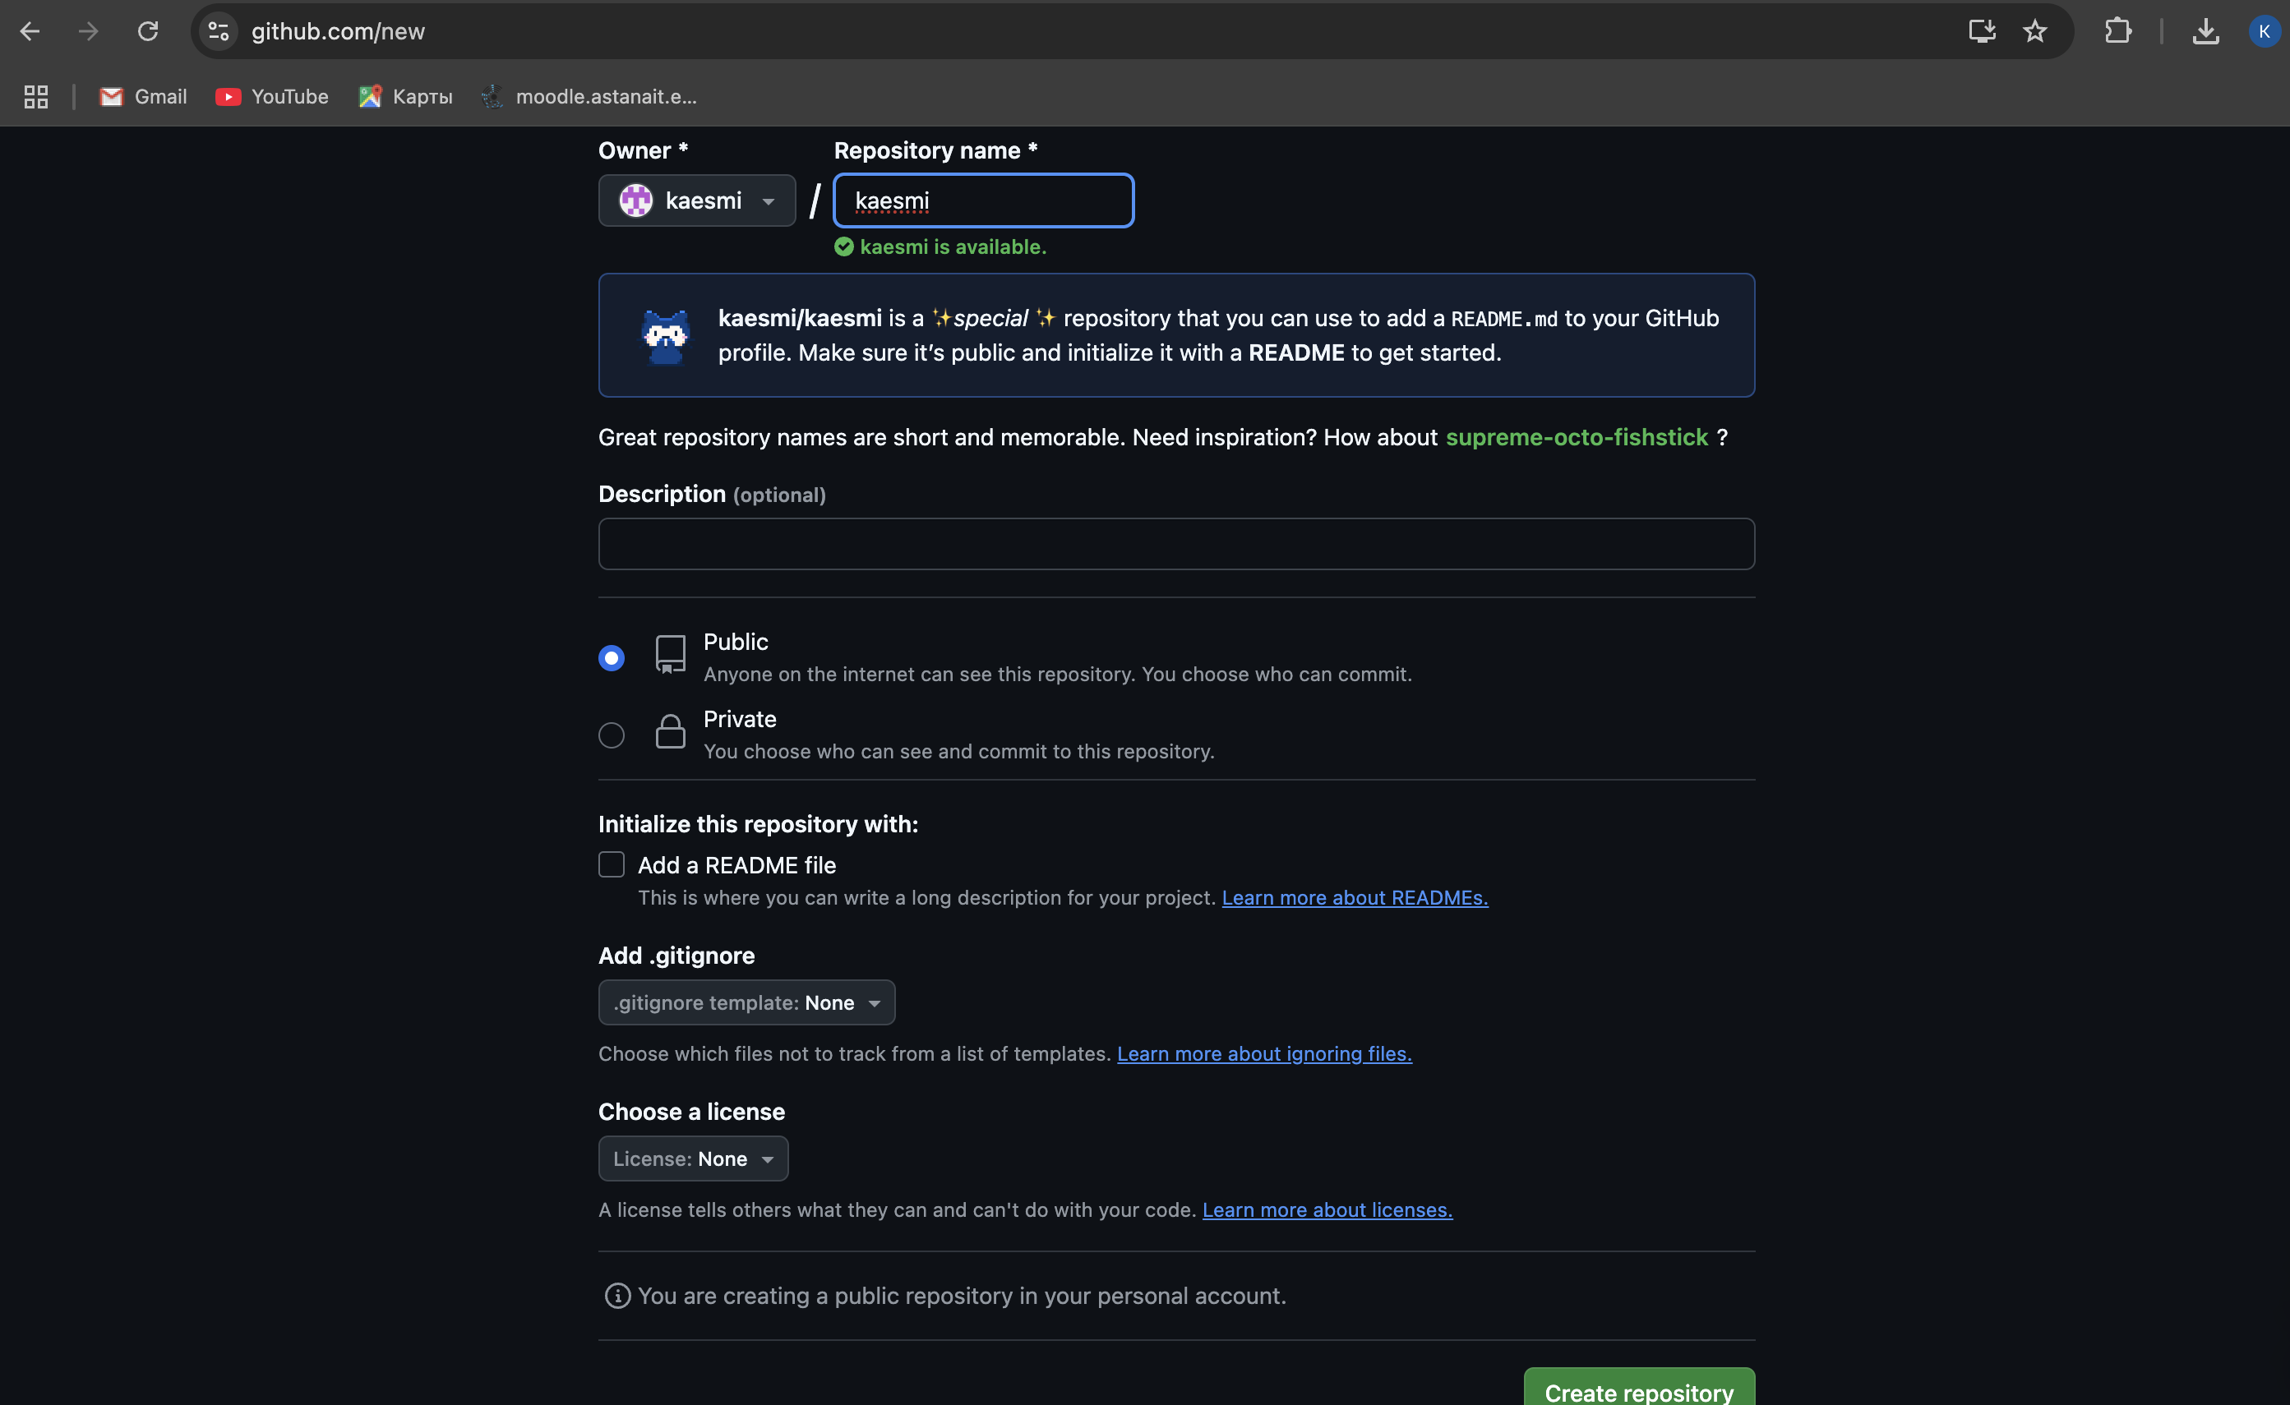

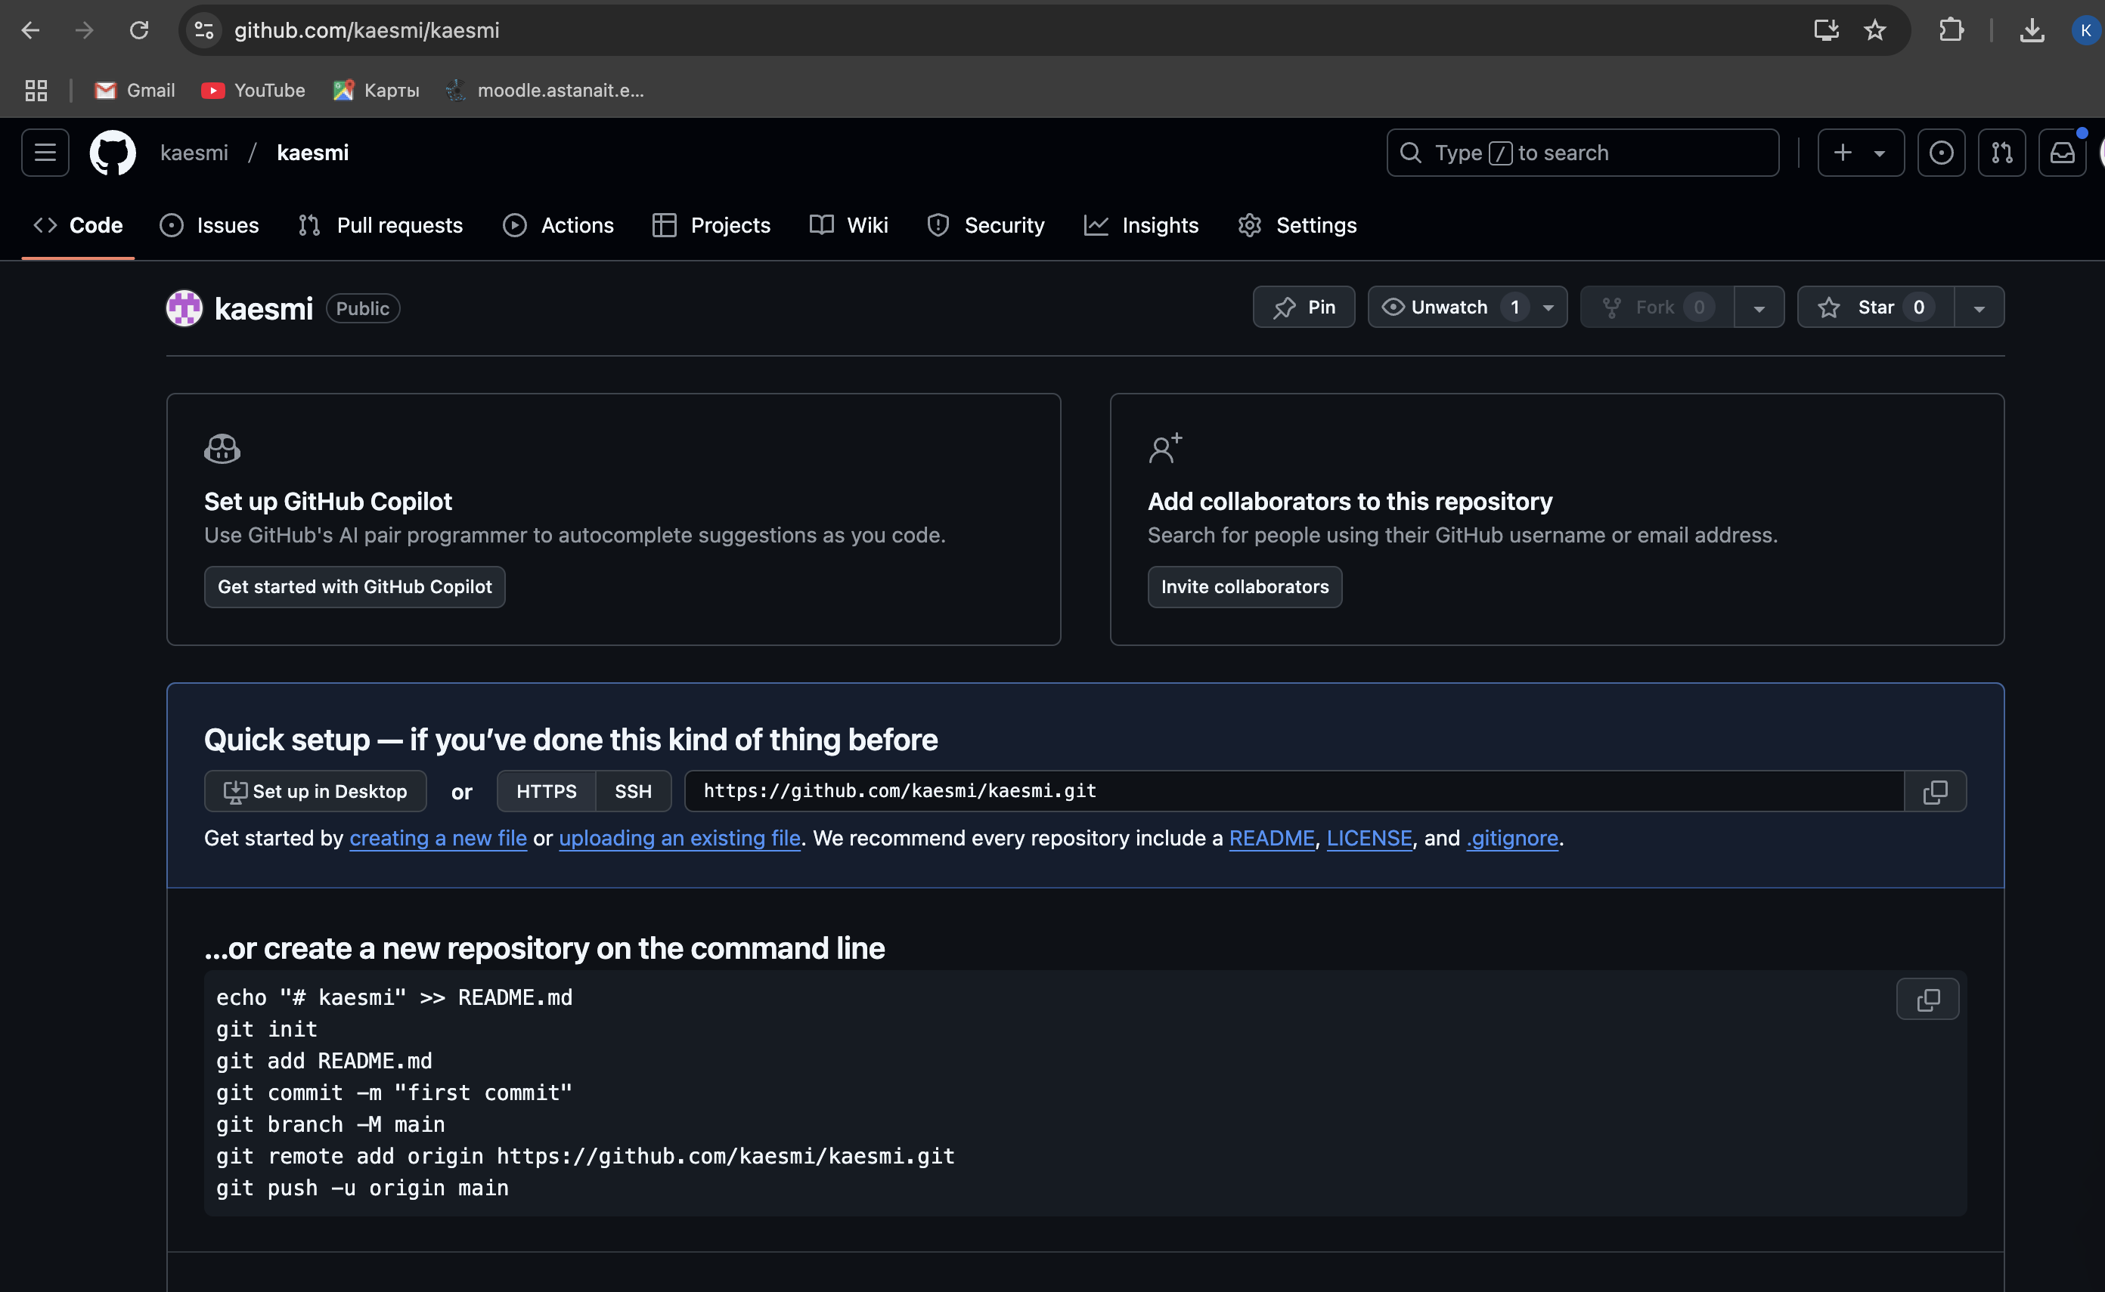

**Regression Testing**

**Objective**: Ensure that recent changes or updates do not negatively impact existing features.

**Test Cases for Regression Testing**:

1. **Login Module**: Verify login functionality works after system update.
2. **Search Feature**: Confirm search results display correctly after bug fixes.
3. **Application Submission**: Validate application form submission remains functional after UI changes.
4. **Payment Gateway**: Ensure payment processing is unaffected after database migration.
5. **General Navigation**: Verify navigation links across the website after adding new menu options.